Promise : promise is a pre defined object part of JS. Promise can be resolved or rejected or in pending.
To handle the promise we need to use then and catch. If promise resolved then get called and if promise rejected catch get call. These operation are asynchronous

Web Service : Giving the service for web application when both the application running using different technologies.
1 SOAP Web Service
2 Rest full web service : in rest full web service we can consume or produce data in any format like XML or json or plain text or html or media type.
API
3. Graph QL
4 RPC style web service.

In Core JS
Fetch() : fetch is a pre defined function which help to handle asynchronous event of data of any types.
Return type of fetch is promise.

Using JS we need to read, write and Update DOM contents properly.

JS provided lot of pre defined library or framework to handle DOM operation in efficient way with standard as well as performance and need to follow design pattern.

Angular : Angular is a open source framework provided by google. Angular internally follow component base architecture . angular follow MVC . in Model View Controller (Component)).

React JS : it is an open source third party library part of Facebook.

Framework Vs Library

Angular React and Vue

SPA : React JS, Angular framework as well as Vue JS support SPA features. In SPA we load only part of the web page rather than loading whole page.

MPA html, css and Core JS we generally develop MPA

React JS: React JS is a open source third party library provided by Facebook. React JS supports SPA features. It supports virtual DOM.
React JS support Component concept. Component is use to control the view or part of the view page.

Frameworkset
Frame tags

In React JS we create component using functional style, arrow style as well as class style.

Node JS : Before Node JS. JavaScript was known as client side scripting language which run in browser environment. But after node JS JavaScript also know as server side as well as client side scripting language.
Spring boot
Asp.net
Php
Python with Django
Node JS

Html, css, JS Rest API Rest API producer
React JS Node JS
Or spring boot
Type script and Agular asp.net
Or
Vue JS

Node JS is a run time environment for JS or Js library or Framework. Before node js we were running JS in browser environment but after node JS we can run JS program outside browser environment. Node js provided lot of modules those module divided into 3 part
- Core module fs, http module etc.
- User defined module : we can create user defined modules.
- Pre defined module or external modules : we can install n number of third party modules to do the projects.

To install third party modules using node js command.
Node js provided tools.
Npm (node package manager)
Npx (node package extension)

Npx with vite framework

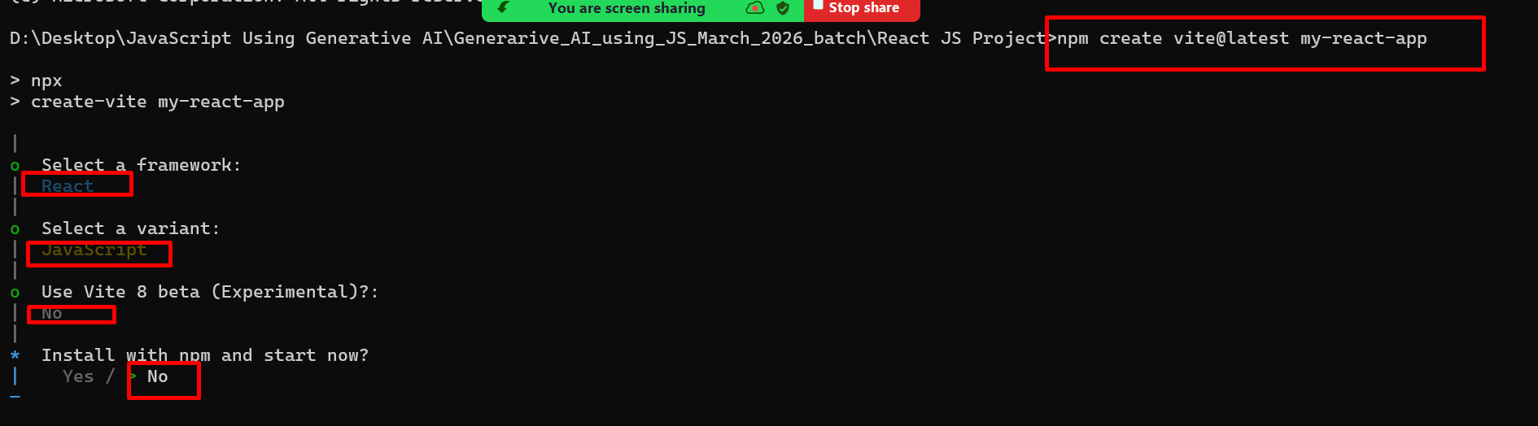

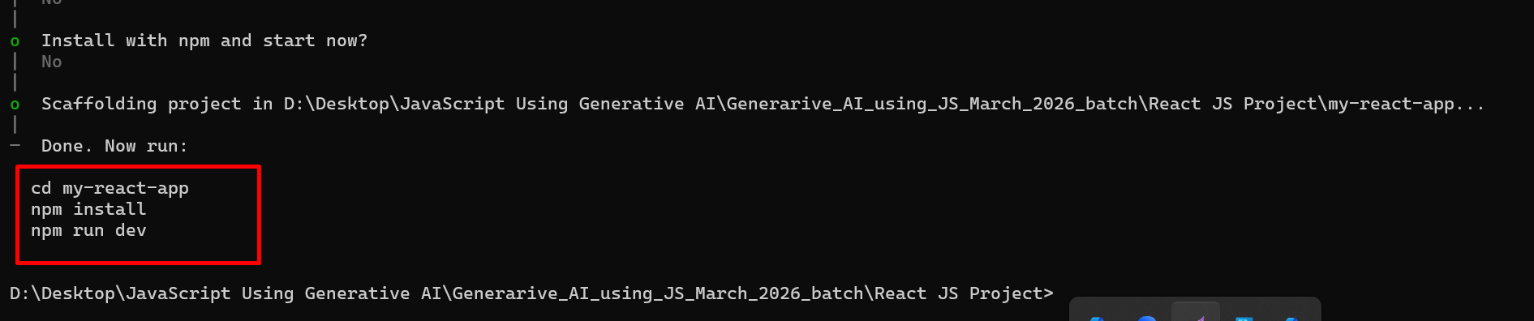

React JS component ie functional style component contains 2 types of variables.
State variable
State variable id use to describe the behavior of the component.
state variable also known as mutable variable. means we can change the value use set functions. Visibility or accessibility of state variable within that component

Props variable: props is type of variable which help to share the data between one component to another component base upon their relationship. Props also known as immutable variables.

React JS Events
React JS Event name follow camel Naming rules.
Value of event is callback with JSX ie {callback}. But JS event takes as string in double quote as function name.
React JS code
<input type="button" value="Increment Counter" onClick={incrementNValue} />

JS events

<input type="button" value="Increment Counter" onclick=”functionName()”/>

In React JS creating state variable with help of react hook
let/const [variableName,functionName]=useState(defaultValue)

props : which help to share the data between one component to another component.

